**CS256: Topics in AI**

**Homework Group Project - AI Knowledge Hub**

**User Guide Document**

Submitted By: Udayan Atreya

Mansi Patel

**AI Learning Resources Platform**

A comprehensive web application for discovering, managing, and sharing AI learning resources. This platform helps users find curated content across various categories including courses, handbooks, GitHub projects, research papers, and blogs.

Application URL - [AI Knowledge Hub](https://ai-resource-hub.onrender.com/).

Repository URL - [CS256-AIGroupProject](https://github.com/slowloris-98/CS256-AIGroupProject)

**Features**

**1. Resource Categories**

* Courses: Online courses from platforms like Coursera, Fast.ai, and MIT OCW
* Handbooks: Comprehensive learning materials and textbooks
* GitHub Projects: Trending and popular AI/ML repositories
* Research Papers: Academic papers and publications
* Blogs: Technical blogs and articles from leading platforms

**2. User Features**

* Account Management: Register and login to access personalized features
* Resource Search: Advanced search functionality across different categories
* Bookmarking: Save and organize favorite resources
* Resource Submission: Submit new resources for admin review
* AI Chat Assistant: Get help and recommendations through the chat interface

**3. Admin Features**

* Resource Management: Review and manage submitted resources
* User Management: Oversee user accounts and permissions
* Database View: Access comprehensive database information

**Getting Started**

**Prerequisites**

1. Python 3.x

2. Flask

3. SQLite

4. Required API Keys:

- Google API Key

- Google Custom Search Engine ID

- Gemini API Key

**Installation**

1. Clone the repository:

```bash

git clone https://github.com/slowloris-98/CS256-AIGroupProject.git

cd CS256-AIGroupProject

```

2. Install dependencies:

```bash

pip install -r requirements.txt

```

3. Set up environment variables in a `.env` file:

```

GOOGLE_API_KEY=your_google_api_key

CSE_ID=your_custom_search_engine_id

GEMINI_API_KEY=your_gemini_api_key

SECRET_KEY=your_secret_key

```

4. Initialize the database:

```bash

flask run

```

**User Guide**

Application URL - [AI Knowledge Hub](https://ai-resource-hub.onrender.com/)

**1. Registration and Login**

- Navigate to `/register` to create a new account

- Provide username, email, and password

- Login at `/login` with your credentials

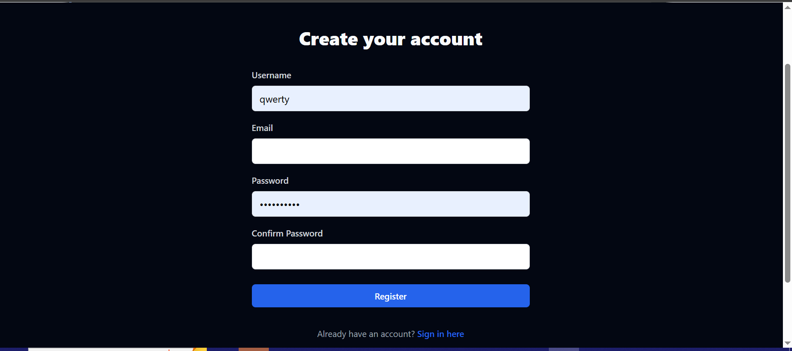

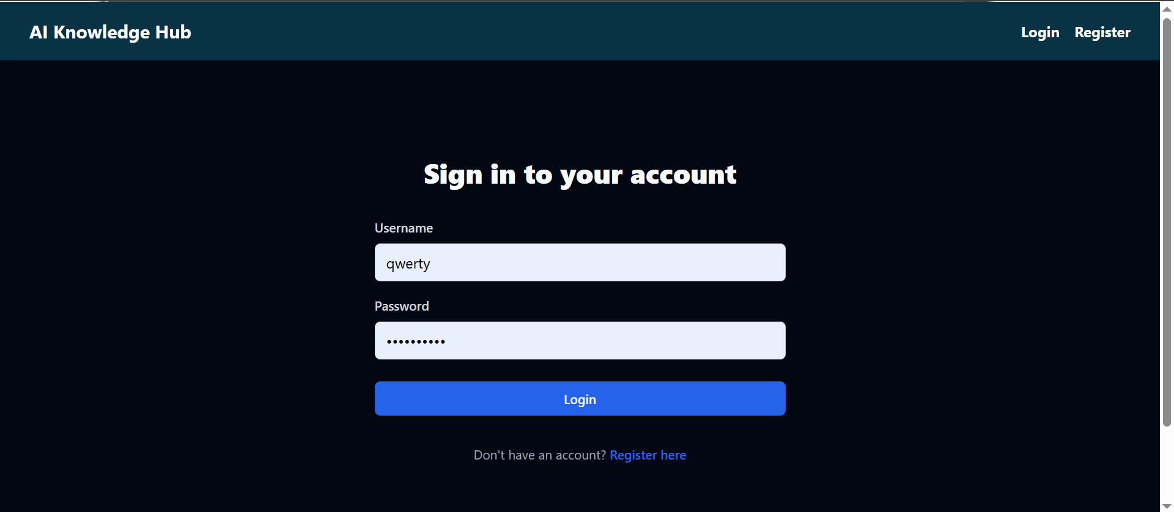

**2. Using the Knowledge Base**

- Access the knowledge base through the main navigation

- Browse different categories using the tabs:

* Courses
* Handbooks
* GitHub Projects
* Research Papers
* Blogs

- Use filters and search to find specific resources

- Bookmark resources for later reference

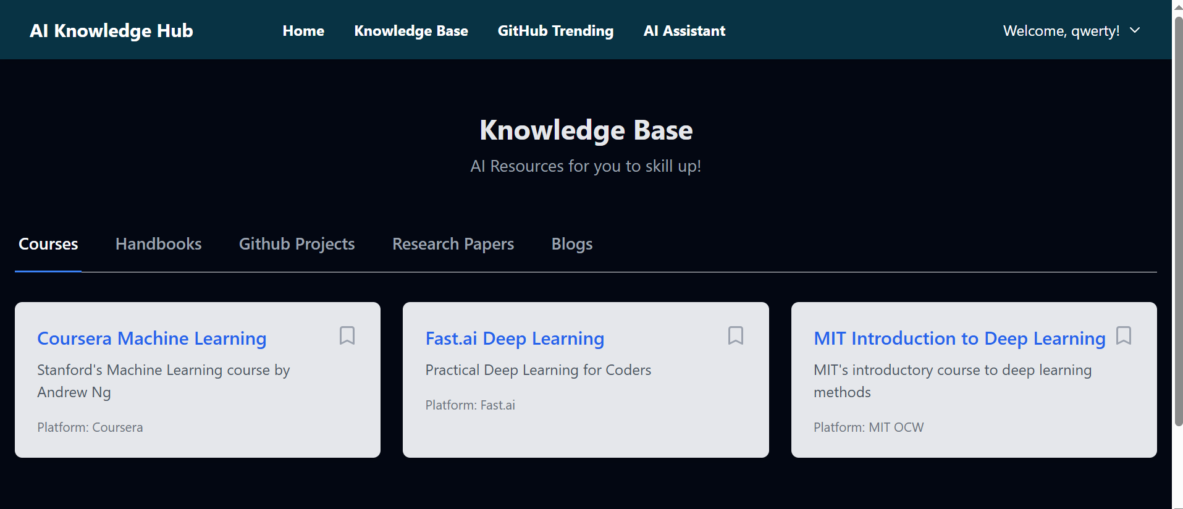

**3. Resource Search**

- Use the search bar on the home page

- Select a category to narrow down results

- Results include:

* Title
* Description
* Source URL
* Category information

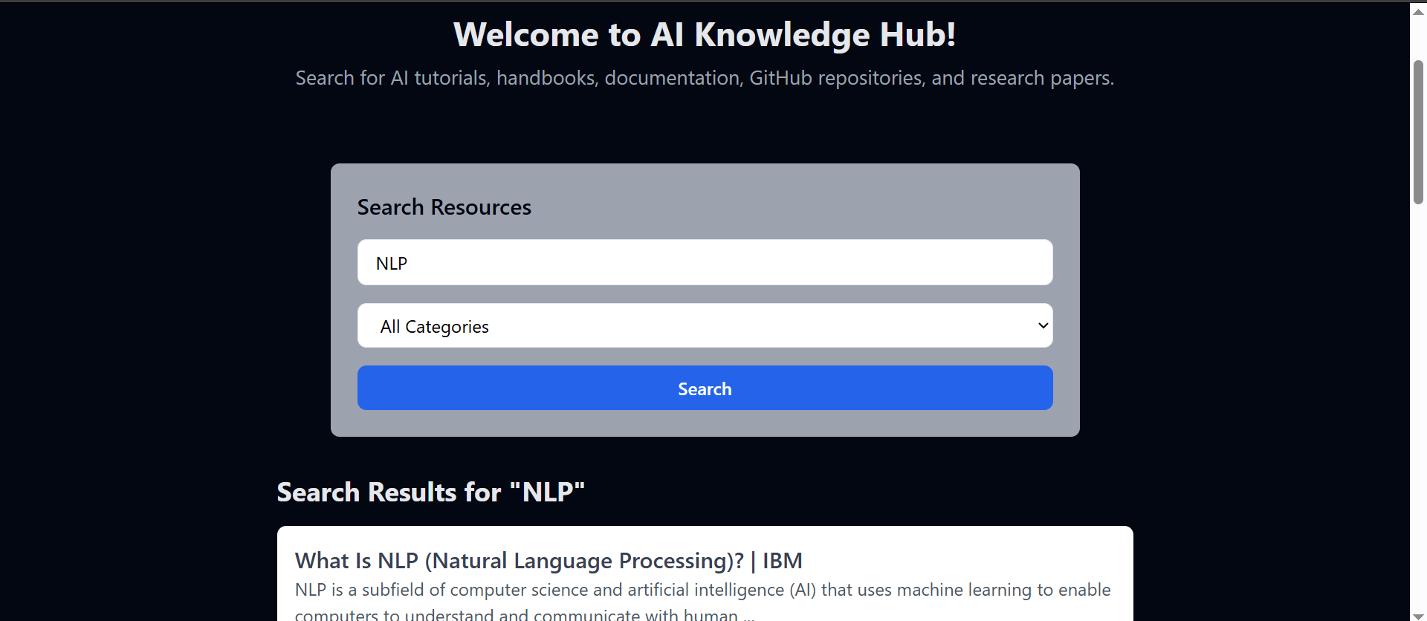

**4. Bookmarking System**

- Click the bookmark icon on any resource to save it

- Access your bookmarks through the "My Bookmarks" section

- Remove bookmarks with a single click

- View bookmark creation date and organize saved resources

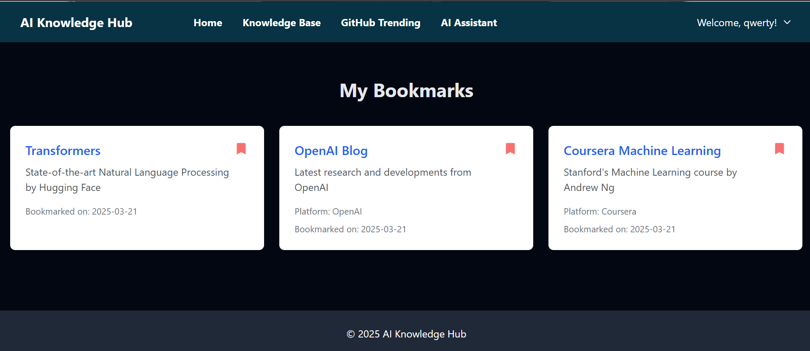

**5. Submitting Resources**

- Click "Submit Resource" in the navigation

- Fill out the resource submission form:

* Title
* URL
* Description
* Resource Type

- Wait for admin approval

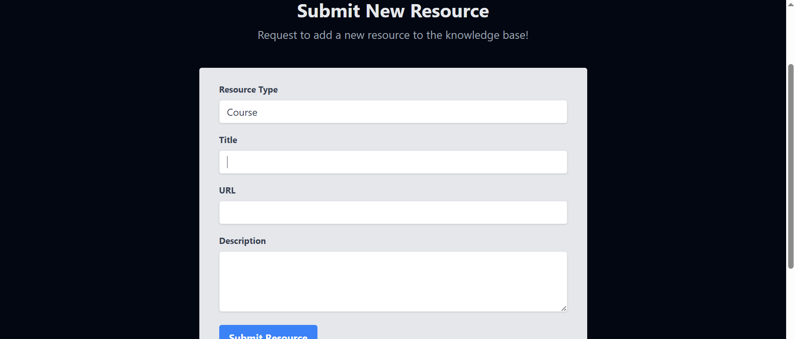

**6. AI Chat Assistant**

- Access the chat interface through the "Chat" button

- Ask questions about:

* Learning recommendations
* Resource suggestions
* AI/ML concepts
* Platform usage help

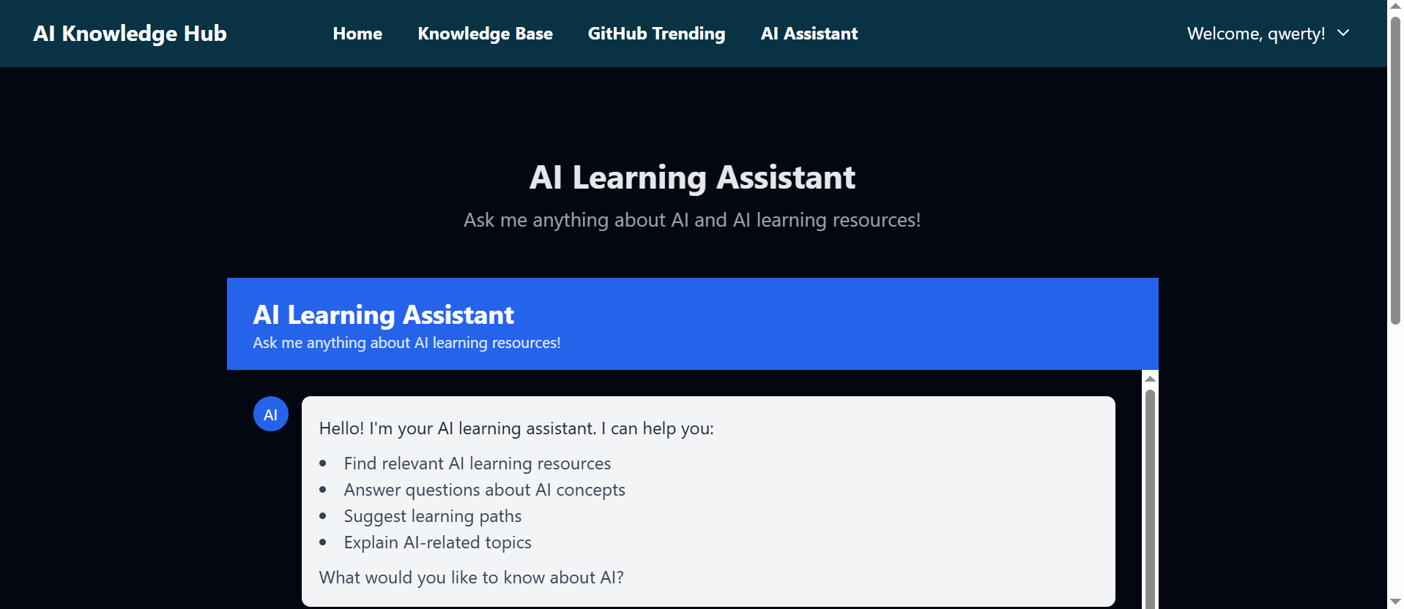

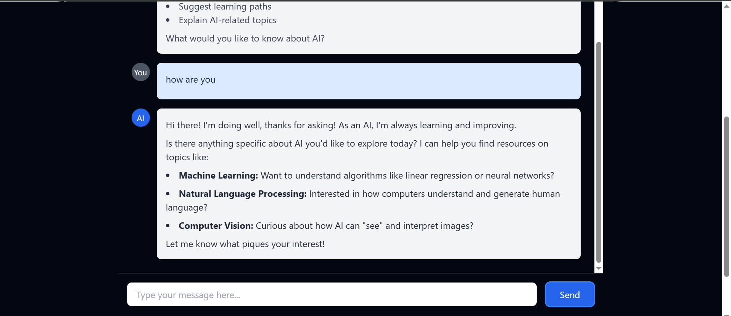

**Admin Guide**

**1. Admin Access**

- Login with admin credentials

- Access admin-specific features through the dashboard

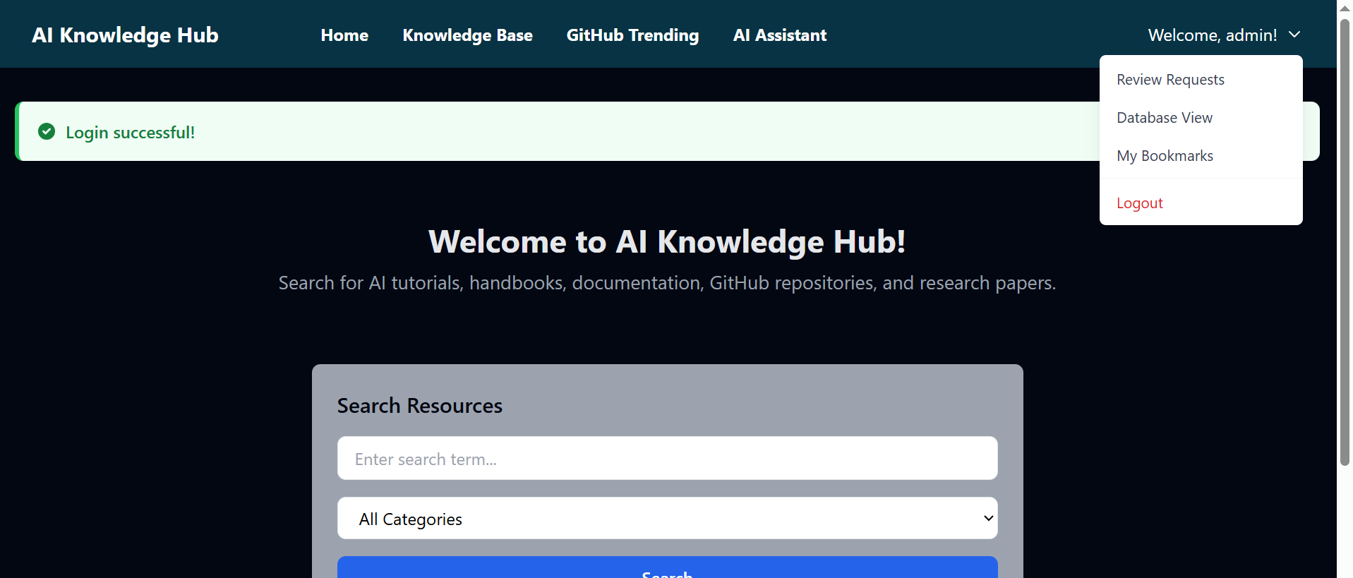

**2. Resource Management**

- Review submitted resources at `/review-requests`

- For each submission:

* Review details
* Approve or reject
* Add review notes
* Monitor submission status

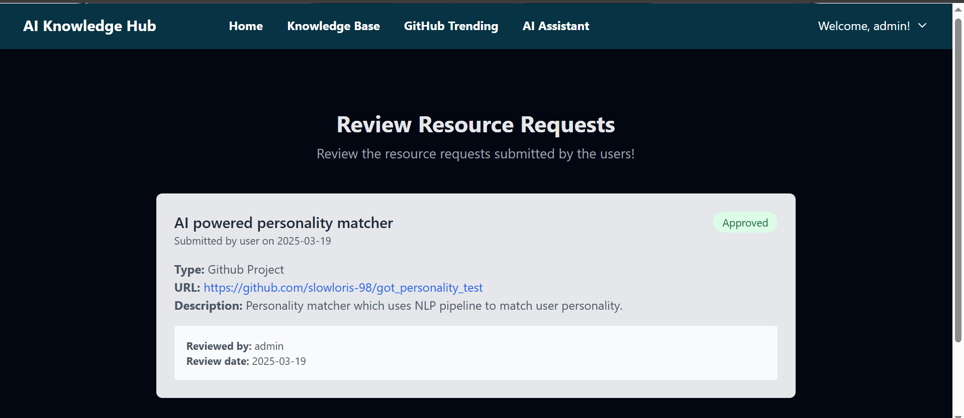

**3. Database Management**

- Access the database view at `/db_view`

- Monitor:

* User accounts
* Resources
* Bookmarks
* Resource requests

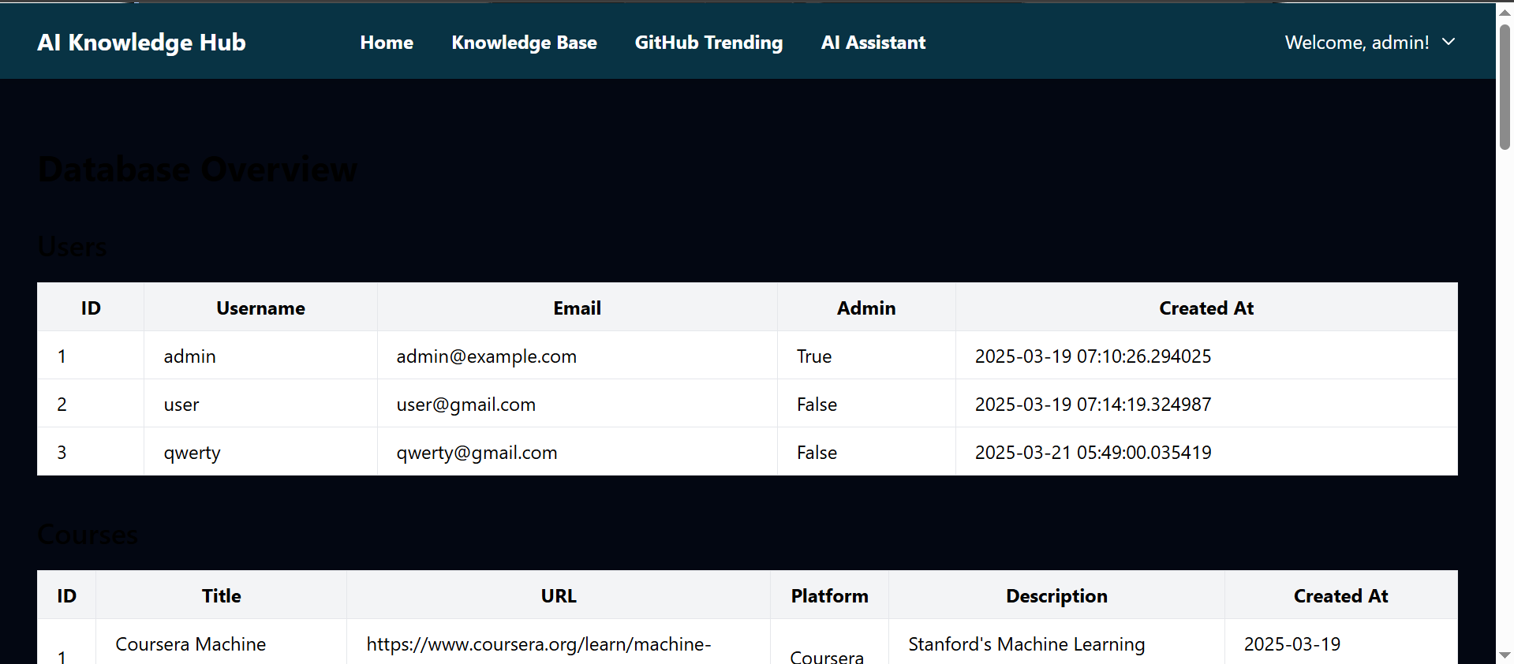

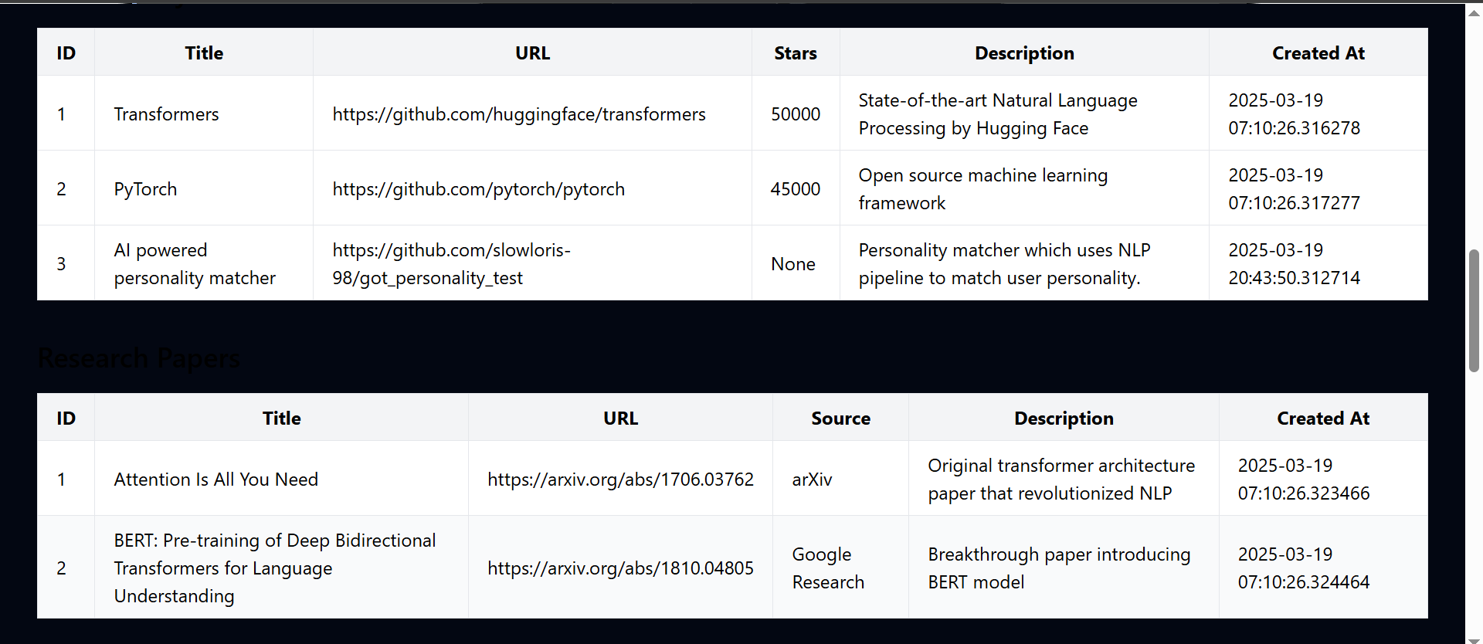

**API Keys Setup**

**1. Google API Key**

- Visit Google Cloud Console

- Create a new project

- Enable Custom Search API

- Generate API key

- Add to `.env` file

**2. Custom Search Engine ID**

- Visit Google Programmable Search Engine

- Create a new search engine

- Get the Search Engine ID

- Add to `.env` file

**3. Gemini API Key**

- Visit Google AI Studio

- Generate API key for Gemini

- Add to `.env` file

**Technical Requirements**

**Minimum System Requirements**

- Python 3.x

- 512MB RAM

- 1GB storage space

- Internet connection for API access

**Supported Browsers**

- Chrome (recommended)

- Firefox

- Safari

- Edge

**Dependencies**

```

flask

flask-login

requests

python-dotenv

google-generativeai

flask-sqlalchemy

```

**Security Notes**

- Keep API keys secure and never commit them to version control

- Regularly update admin passwords

- Use strong passwords for all accounts

- Keep the system and dependencies updated

**Support**

For additional support or questions:

- Submit an issue on the repository

- Contact the system administrator

- Check the documentation for updates